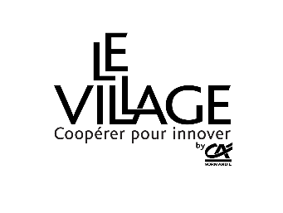
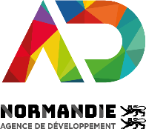
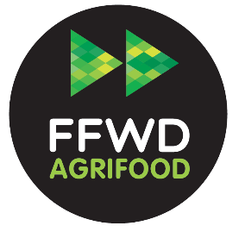

APPLICATION FORM
FAST FORWARD AGRIFOOD

As an extension of the Fast Forward Accelerator (FFWD), AD Normandie and the Village by CA Normandie are launching an acceleration programme specific to the agricultural and agri-food sectors: AgriTech, AgroTech and FoodTech.
This new scheme is aimed at start-ups with innovation projects in Normandy or in connection with the region (R&D projects, subcontracting, industrial partnerships, etc.).

This form must be completed so that your application can be taken into account.

Sending this application form implies unreserved acceptance of the regulations (available on ffwdnormandie.com or on request by e-mail to rosemarie.tostivint@adnormandie.fr) of which the applicants certify having read.

In order to study your application, you may be asked to provide additional information at a later date, in particular:
- Organisation chart / capitalisation table of the company
- KBIS
- Forecast accounts
- Balance sheets for the last 3 fiscal years
- manager's CV

File to be sent to rose-marie.tostivint@adnormandie.fr or to be completed on www.ffwdnormandie.com.
before Monday, April 20, 2020 11:30 p.m

For information, you can contact :

Laure LECLERCQ
Manager
Fast Forward Normandie
laure.leclercq@adnormandie.fr
+332.50.53.10.93 - +337.88.44.93.84

Rose-Marie TOSTIVINT
Project Manager
Fast Forward Normandie
rose-marie.tostivint@adnormandie.fr
+332.31.15.81.50 - +336.84.15.07.51

Guillaume BERRANGER
Start-up Manager
Village by CA Normandie
guillaume.berranger@levillagebyca.com
+336.28.56.24.93 –+332.31.55.66.6
Contact (name/first name) :
Function in the company :
Tel :
Mail :

1_ Your company
trade name :  Field of activities :  Adress:  Country :  Website : | Creation date :  Capital:  Legal forme :  Employees :
Group membership : ☐ yes ☐ no
> If yes: group size (consolidated headcount):

Distribution of capital :
Shareholders  (individual or legal entity) | Percentage

2_ Project : origin, concept, stage of development, value proposition

3_ Product / Offer : main features, technical characteristics, innovation, competitive advantage, intellectual property

4_ Business model

5_ Market : size, stakeholders, competition

6_ Clients : targets, distribution channels…

7_ Team : management team, distribution of roles, skills

8_ Growth & funding

 | 2018 | 2019 |  | 2020 | 2021
 | realized | realized | estimated | estimated | estimated
Financal year duration (in months)
Sales Revenue (K€)
EBITDA (en K€)
Working capital requirements (K€)
Equity (K€)
Cash flow (K€)
Employees

Fundraising activities (date, amount, investors):

Financing needs and sequencing (N, N+1, N+2,...):

Request for financing proposed by Normandie Participations and its co-investor Crédit Agricole Innove en Normandie (up to €150k): ☐ yes ☐ no

9/ Needs for support

Have you ever been accompanied by other structures?
☐ yes ☐ no

if so, which ones?

Why do you want to join the Fast Forward Agrifood program (support, financing, experimentation, others...)?

What are your expectations and needs in terms of industrial or research partnerships?
What solution do you wish to experiment with, with what type of partners, over what period of time?

The information collected is processed electronically by the Normandy Development Agency (AD Normandie). In accordance with the French Data Protection Act of 6 January 1978, you have the right to access, rectify and oppose information concerning you, which you can exercise by contacting the Data Protection Officer: dpo@adnormandie.fr
For more information please consult the privacy policy of AD Normandie.

